App Name: Connect_Sphere

Overview

Connect Sphere is a lightweight, full-stack social media platform developed entirely from scratch using PHP, MySQL, HTML5, CSS3, and JavaScript — with no external frameworks or CMS tools involved.
It’s designed to deliver a modern social networking experience, allowing users to create personal profiles, share posts, upload images, and chat privately in real time — all within a secure, intuitive, and responsive interface.

Core Features

User Accounts & Authentication
Users can easily register with their name, unique email, password, and an optional profile picture.
Passwords are securely stored using password_hash() and login sessions are managed through PHP sessions ($_SESSION) to maintain security and user persistence.

Password Recovery (Token-Based Reset)

A built-in token-based password reset system allows users to safely recover their accounts using a temporary reset link.
This ensures that users can regain access conveniently while keeping their data secure.

Timeline / Dashboard

After logging in, users access a personalized dashboard where they can create posts (text or images).
Posts appear in reverse chronological order, complete with timestamps and linked profiles.

Profile Management

Each user has a dedicated profile page displaying their name, photo, and posts.
Profiles can be updated anytime — users can change their display name or upload a new picture seamlessly.

Smart Search

An AJAX-powered search bar allows users to find others instantly, showing live suggestions without reloading the page.

Private Messaging

A built-in real-time chat system (using AJAX polling) lets users send and receive private messages dynamically — no refresh required.

Security & Data Protection

- All SQL queries use prepared statements (PDO) to prevent SQL injection.
- User inputs are sanitized and escaped to block XSS attacks.
- Passwords are hashed before storage for maximum protection.

Responsive Design

The UI is built with custom CSS, ensuring a clean, minimal, and adaptive layout across desktop, tablet, and mobile screens.

Technical Highlights

- 100% custom-built using core web technologies (PHP, MySQL, JS, CSS, HTML).
- AJAX polling for instant message updates.
- Well-organized folder structure:
  - includes/ – shared functions and configuration
  - uploads/ – profile and post images
  - css/ – stylesheets
  - js/ – JavaScript logic
  - messages/ – chat and message handling
- Token-based password reset integrated for secure account recovery.

Purpose

Connect Sphere was developed to showcase full-stack web development skills — combining interactive front-end design, secure backend logic, and seamless database integration.
It captures the essence of modern social media platforms like Facebook or Instagram, focusing on security, simplicity, and interactivity, while remaining lightweight and easy to maintain.

Register Screen:

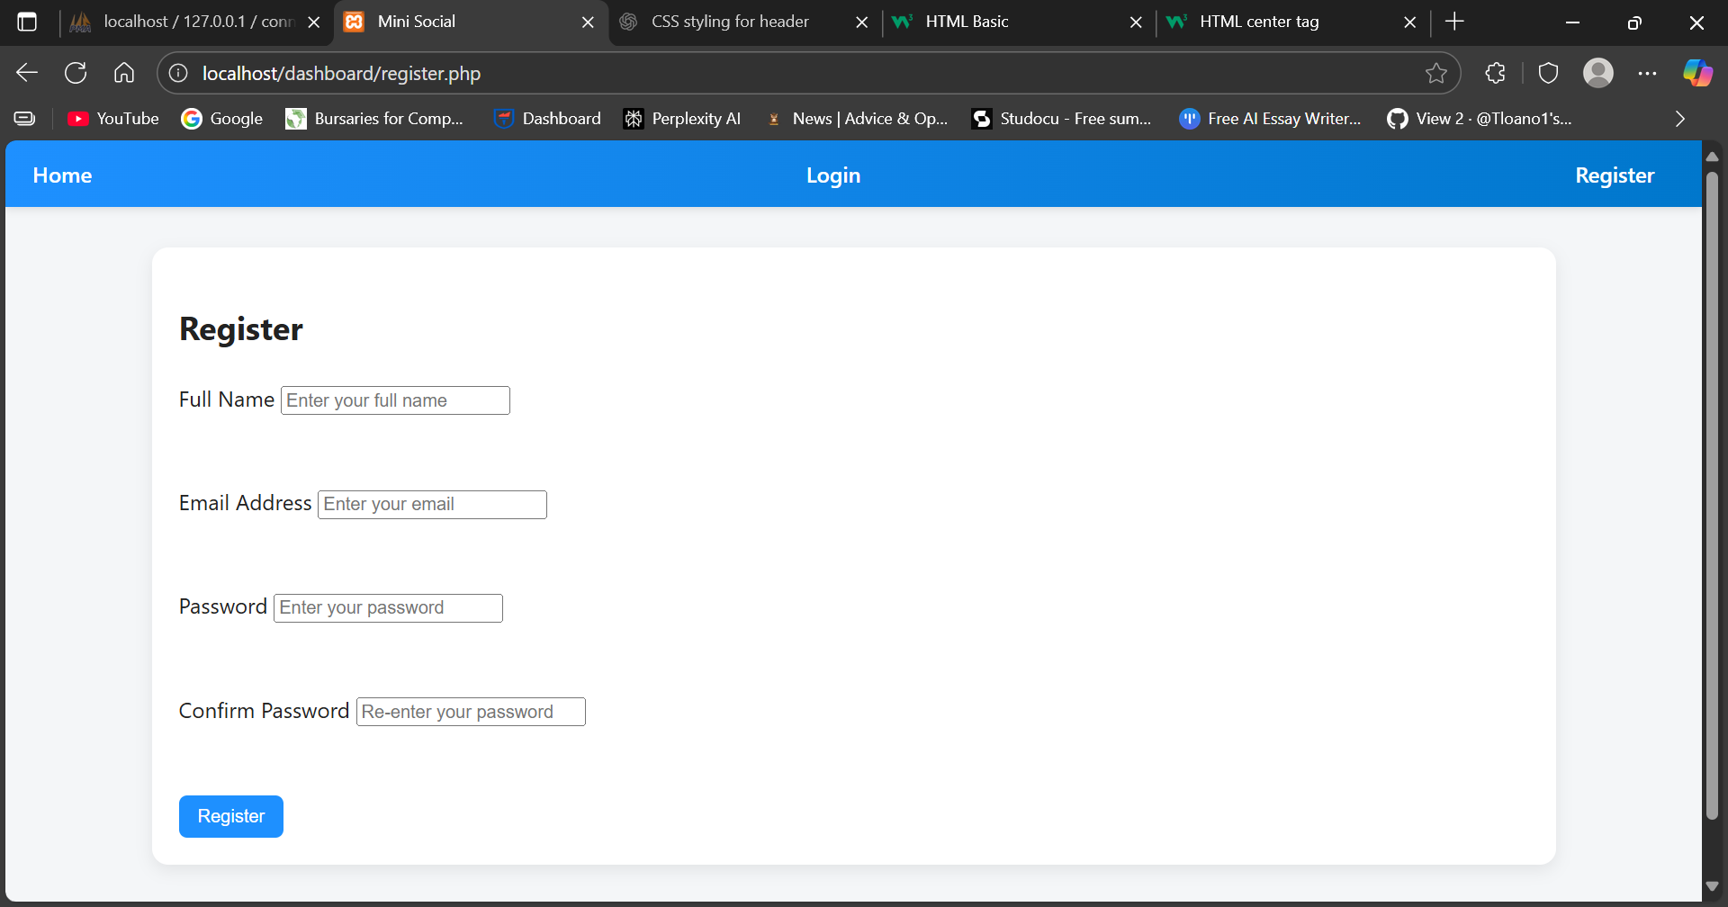

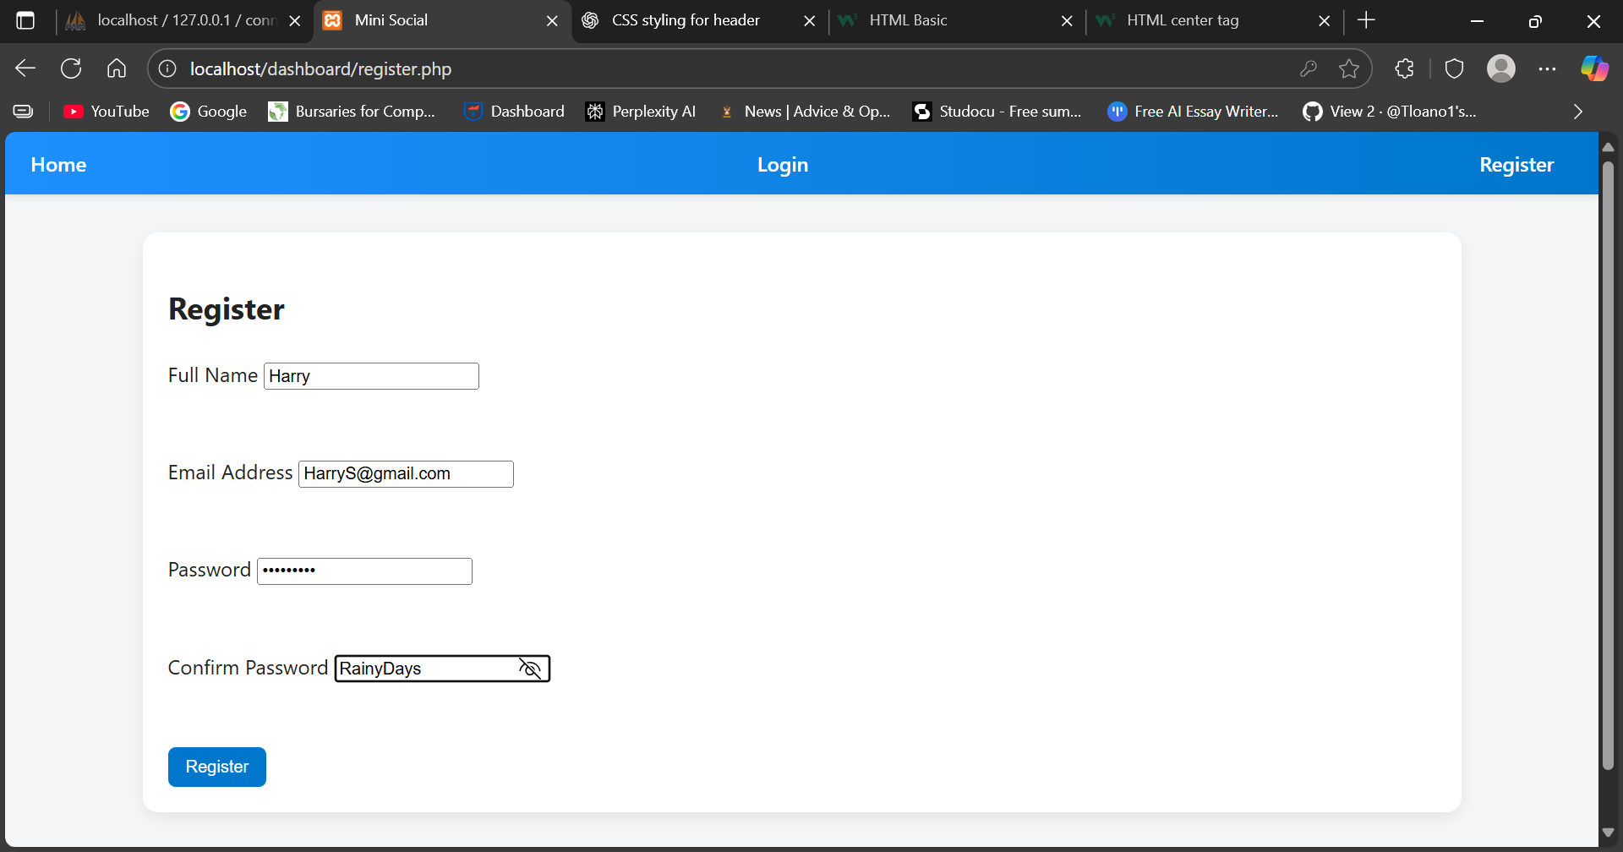

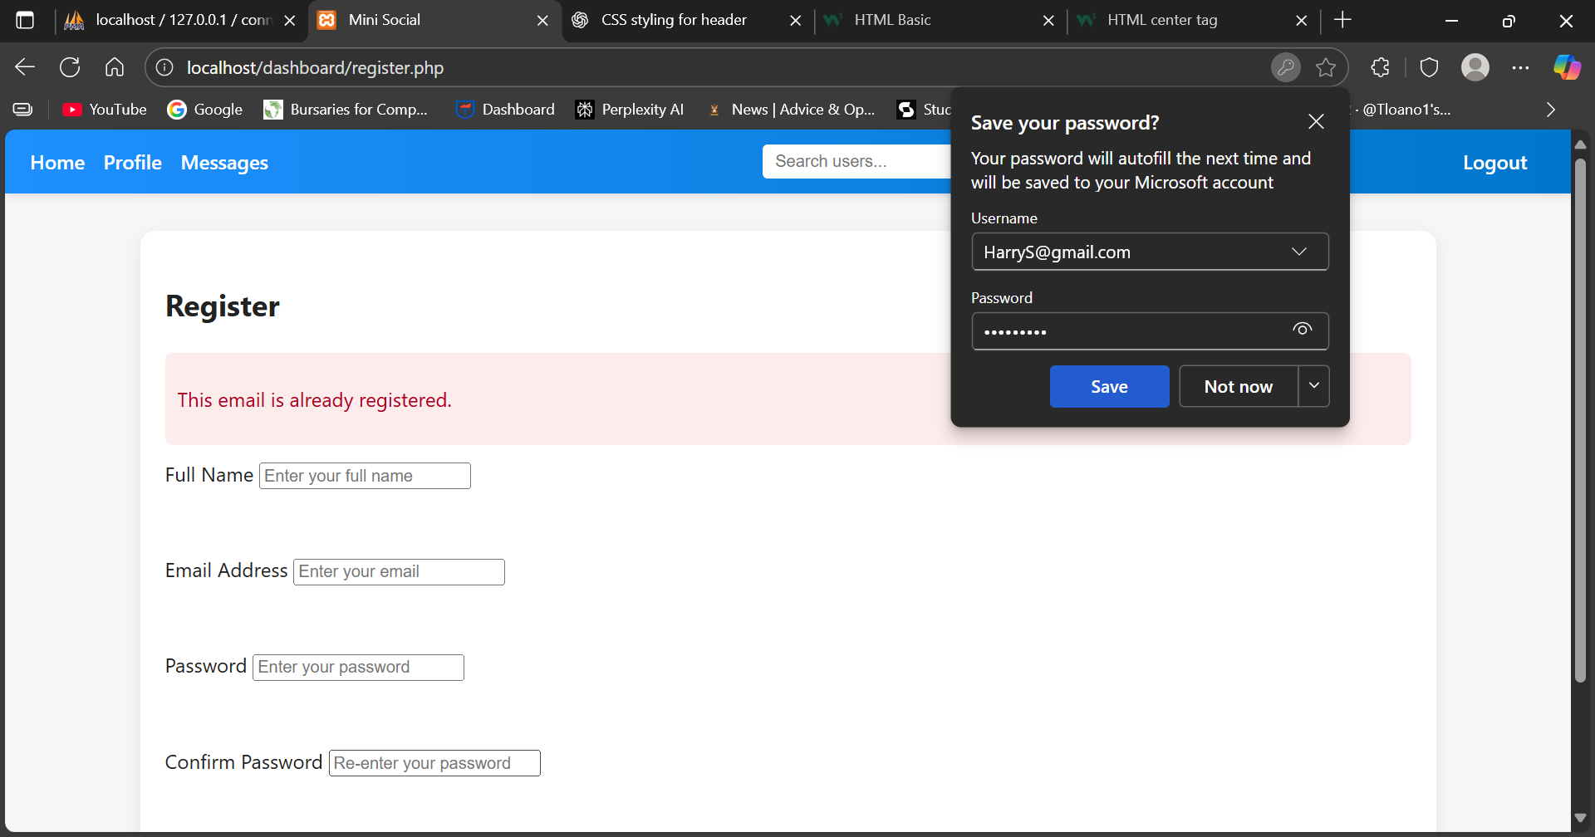

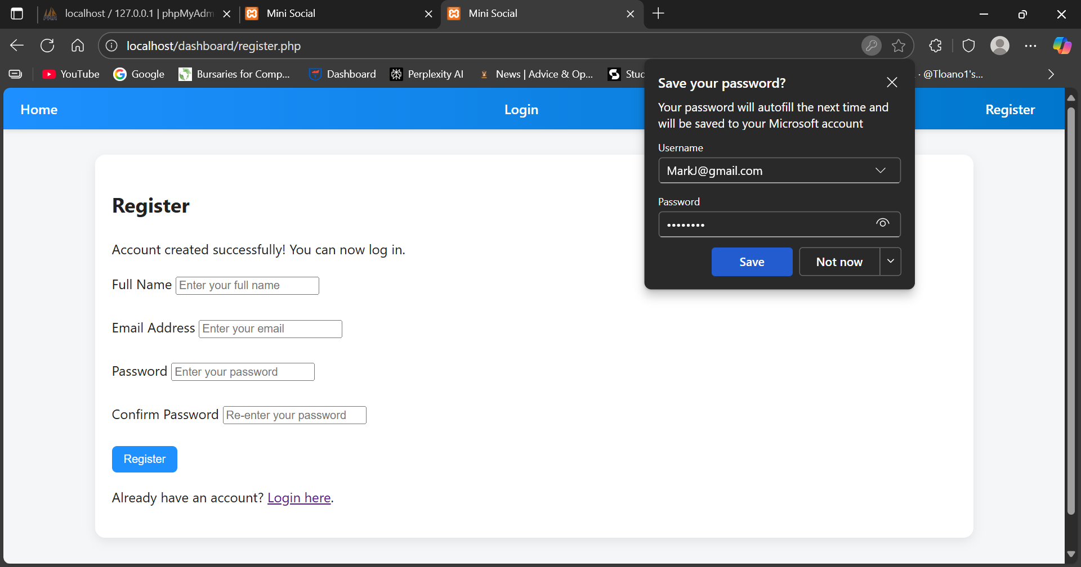

Login Screen

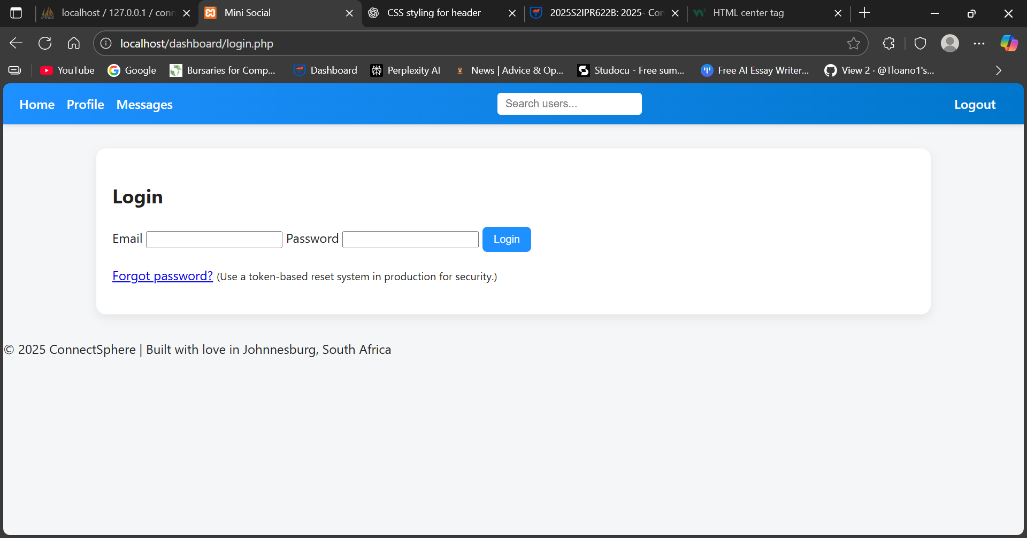

Create Post screen

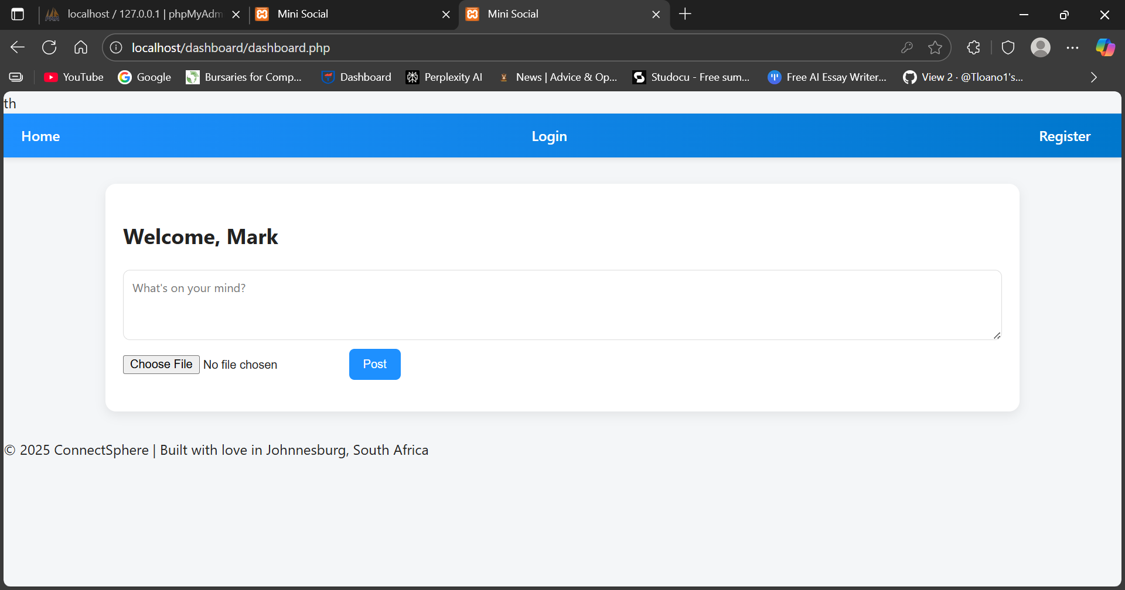

Dashboard Screen

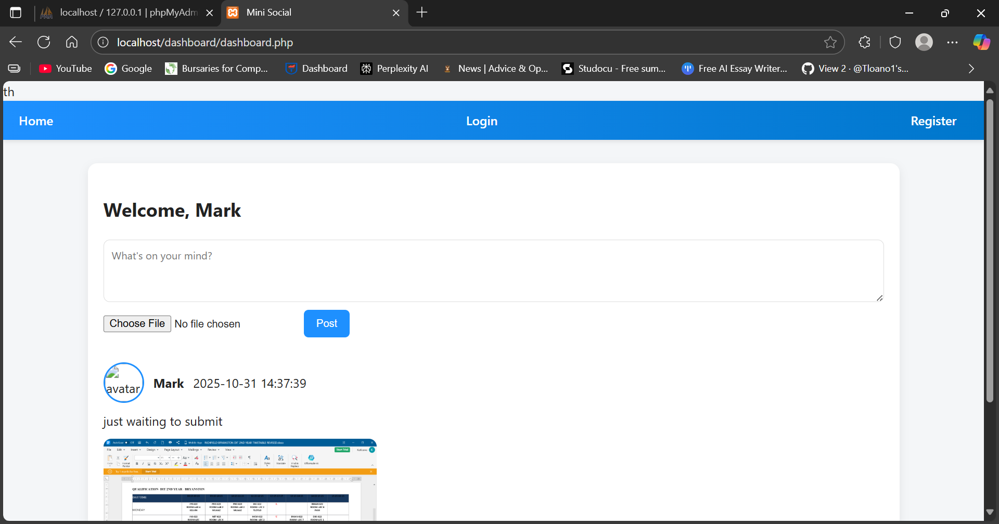

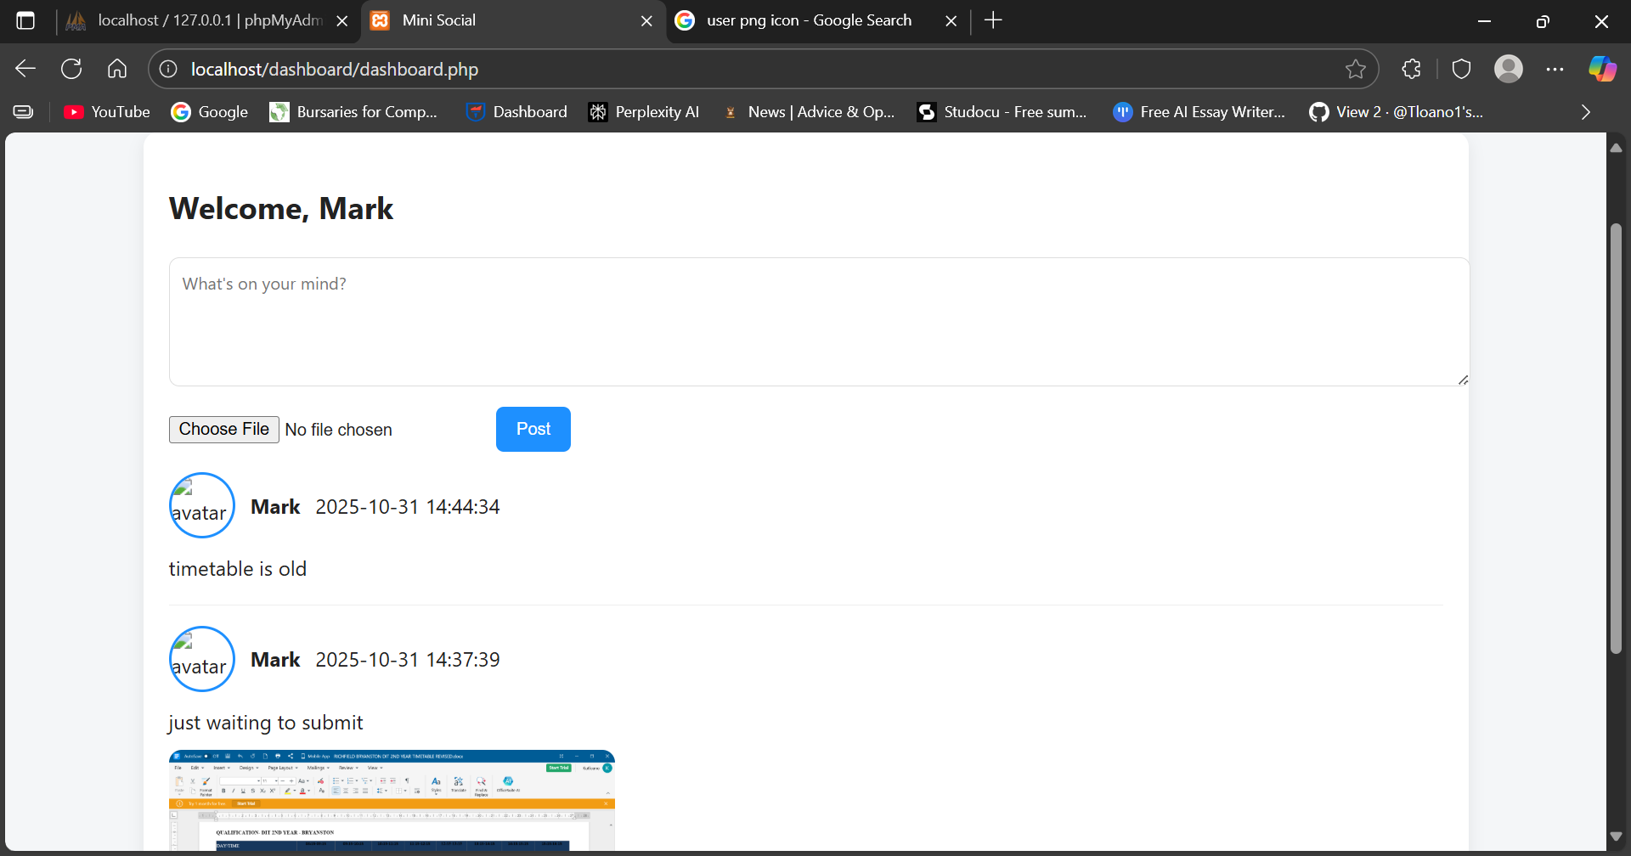

Profile screen

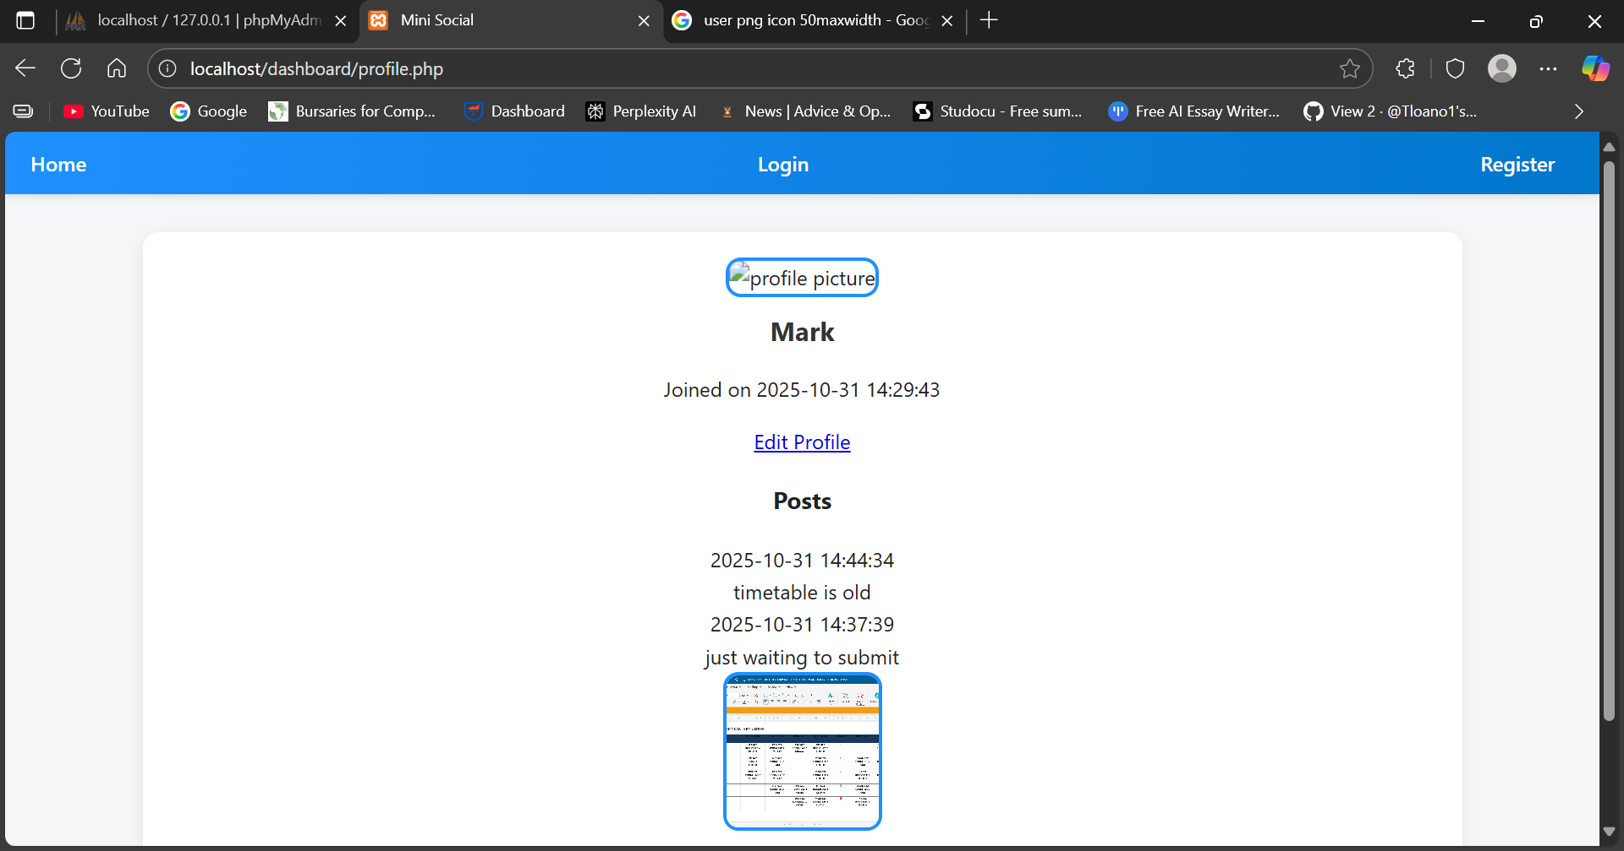

Edit profile screen

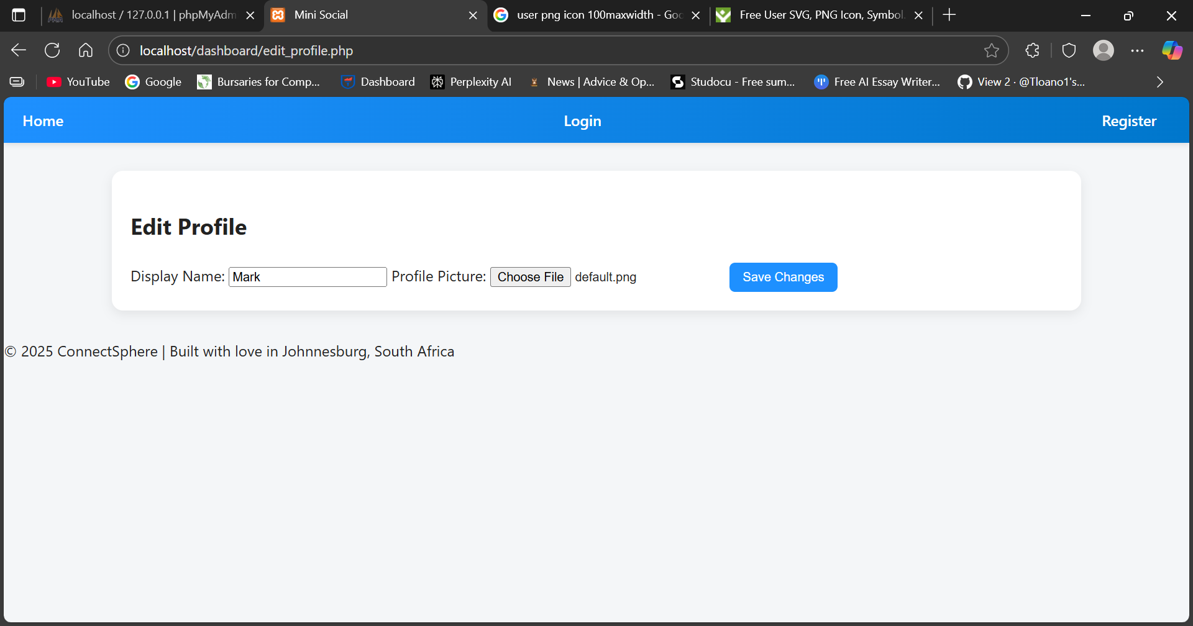

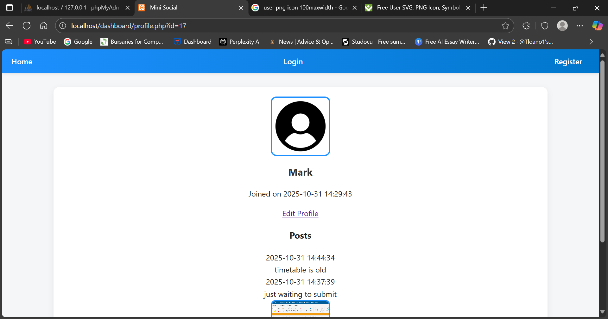

Search Screen

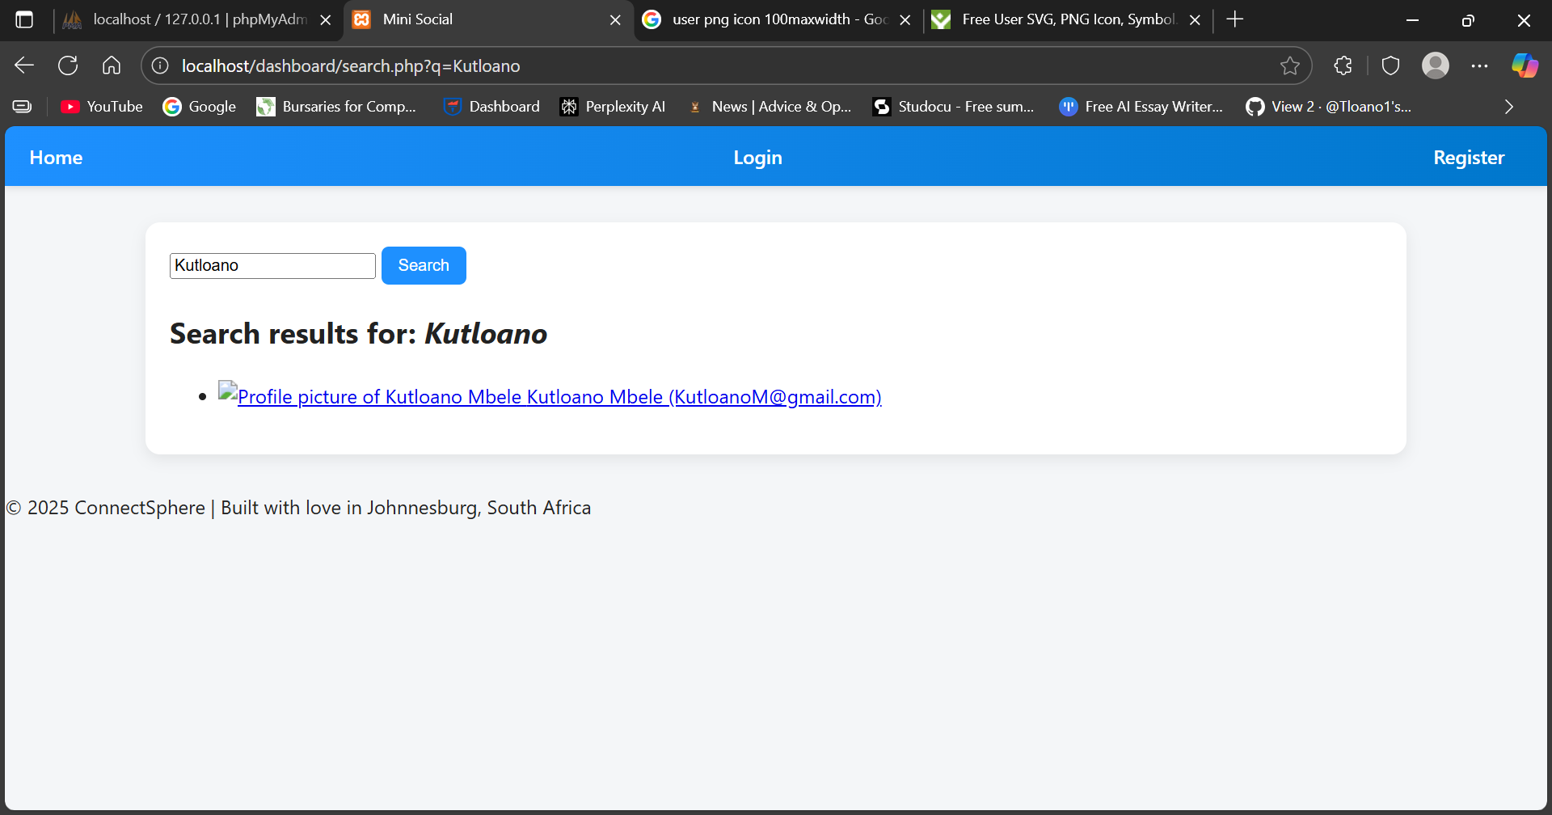

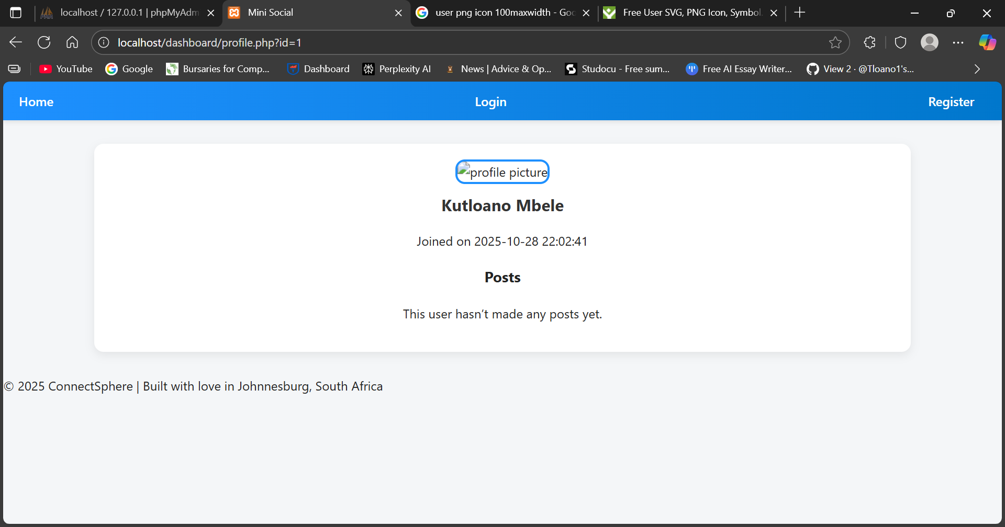

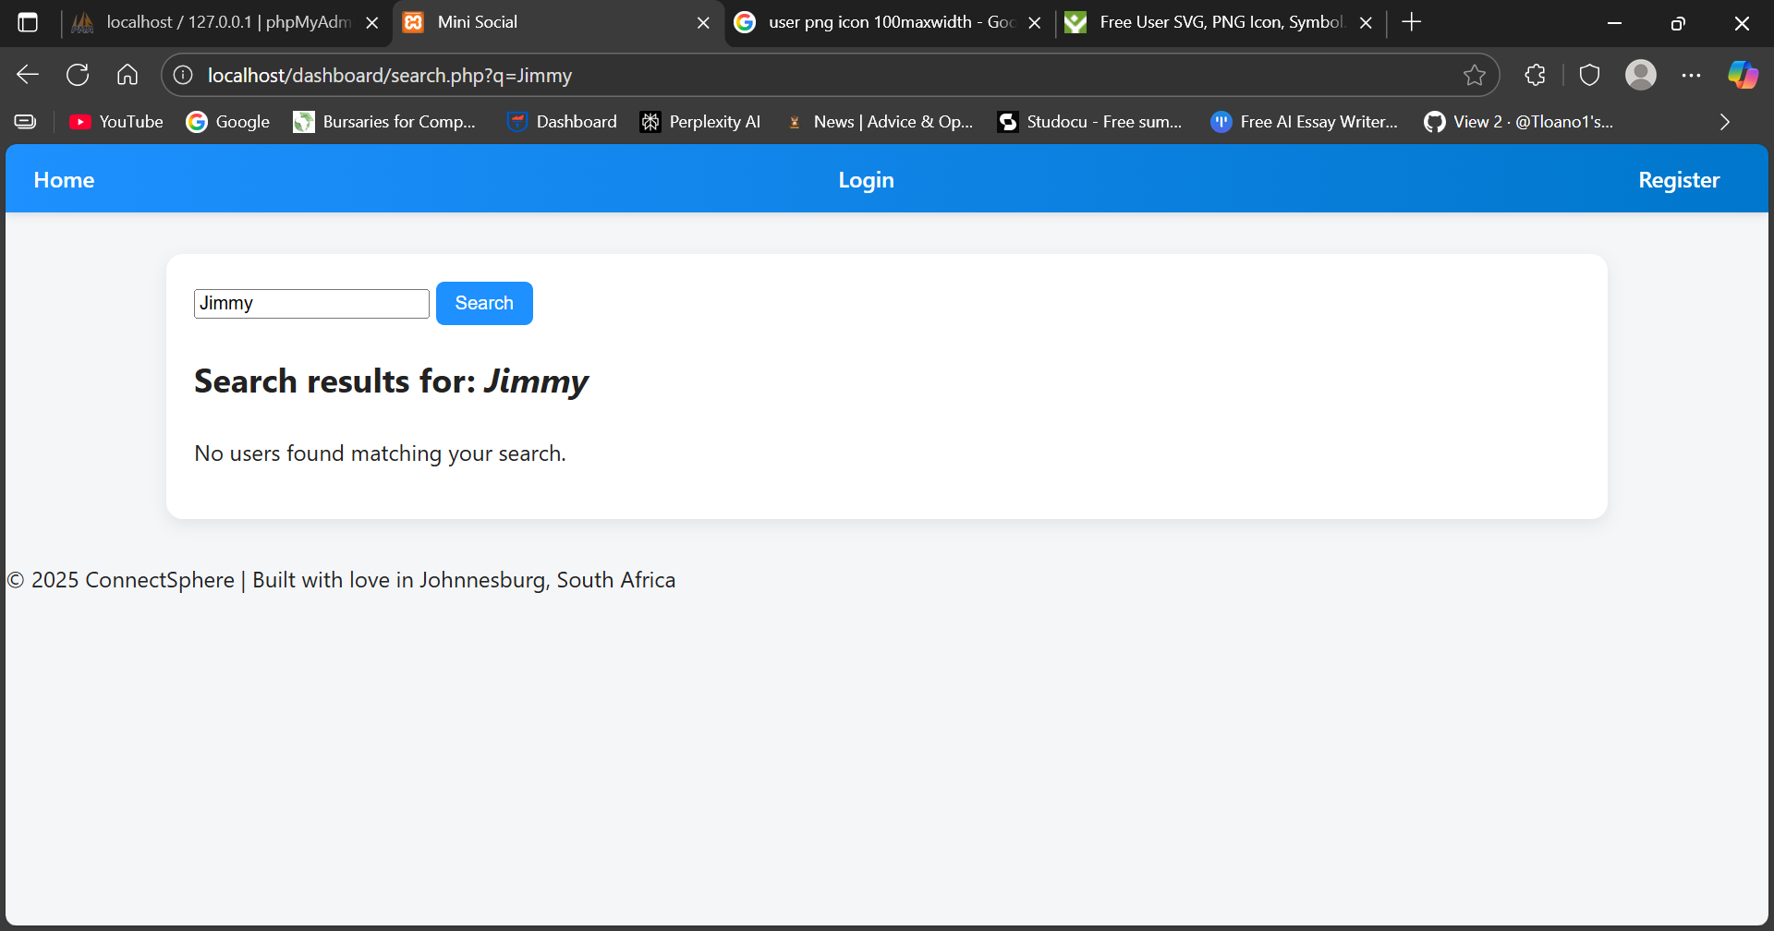



Message Screen

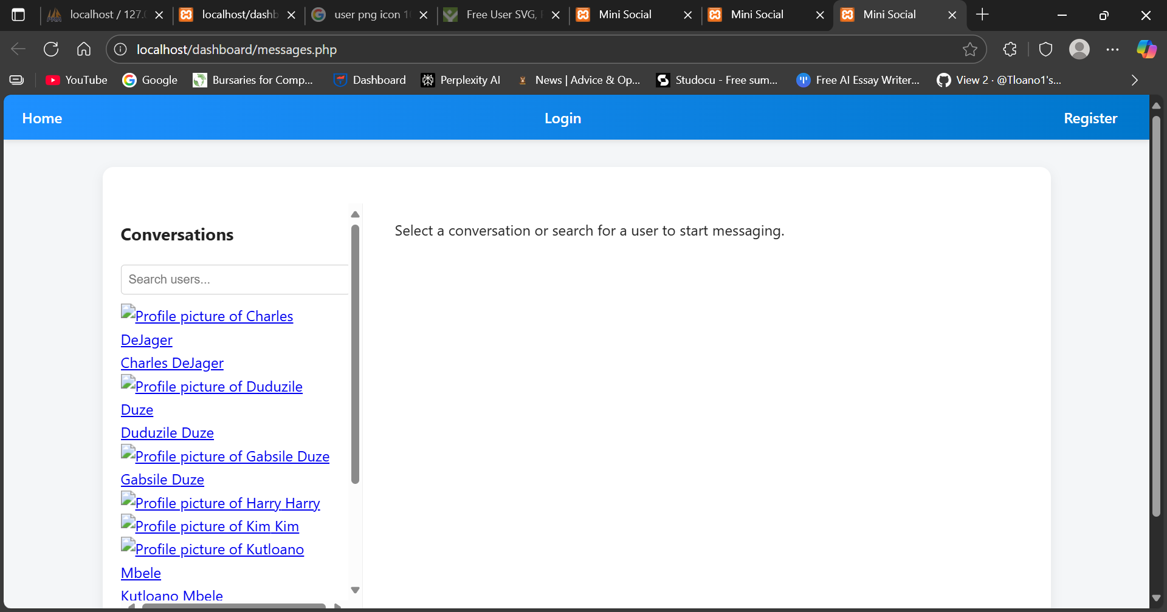

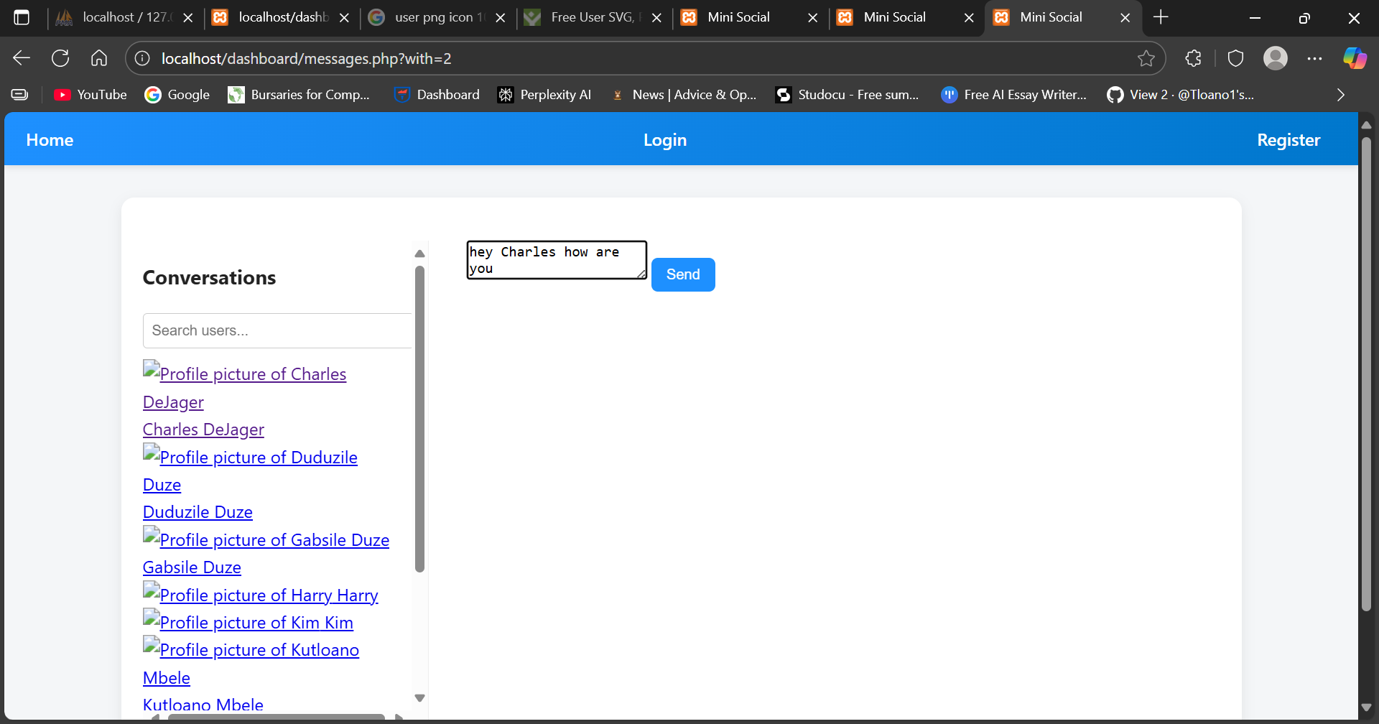

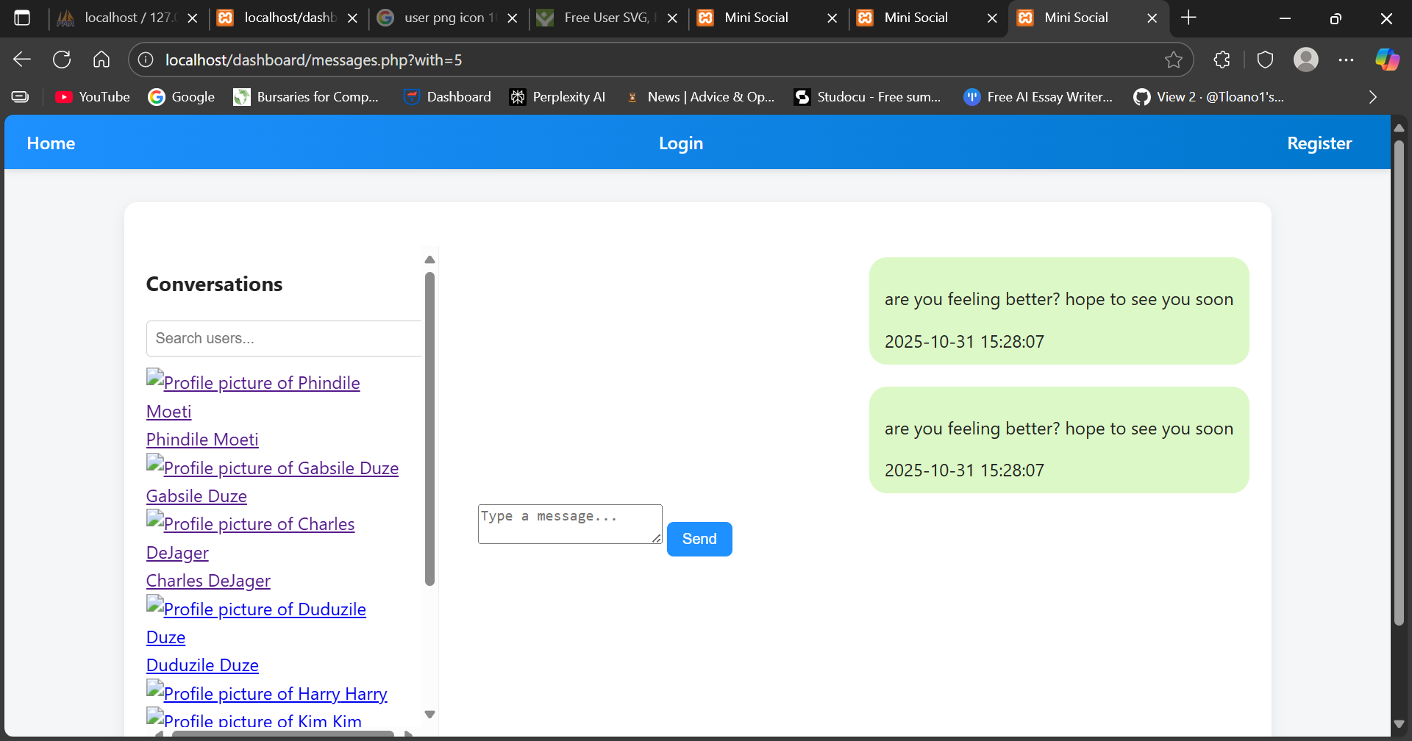

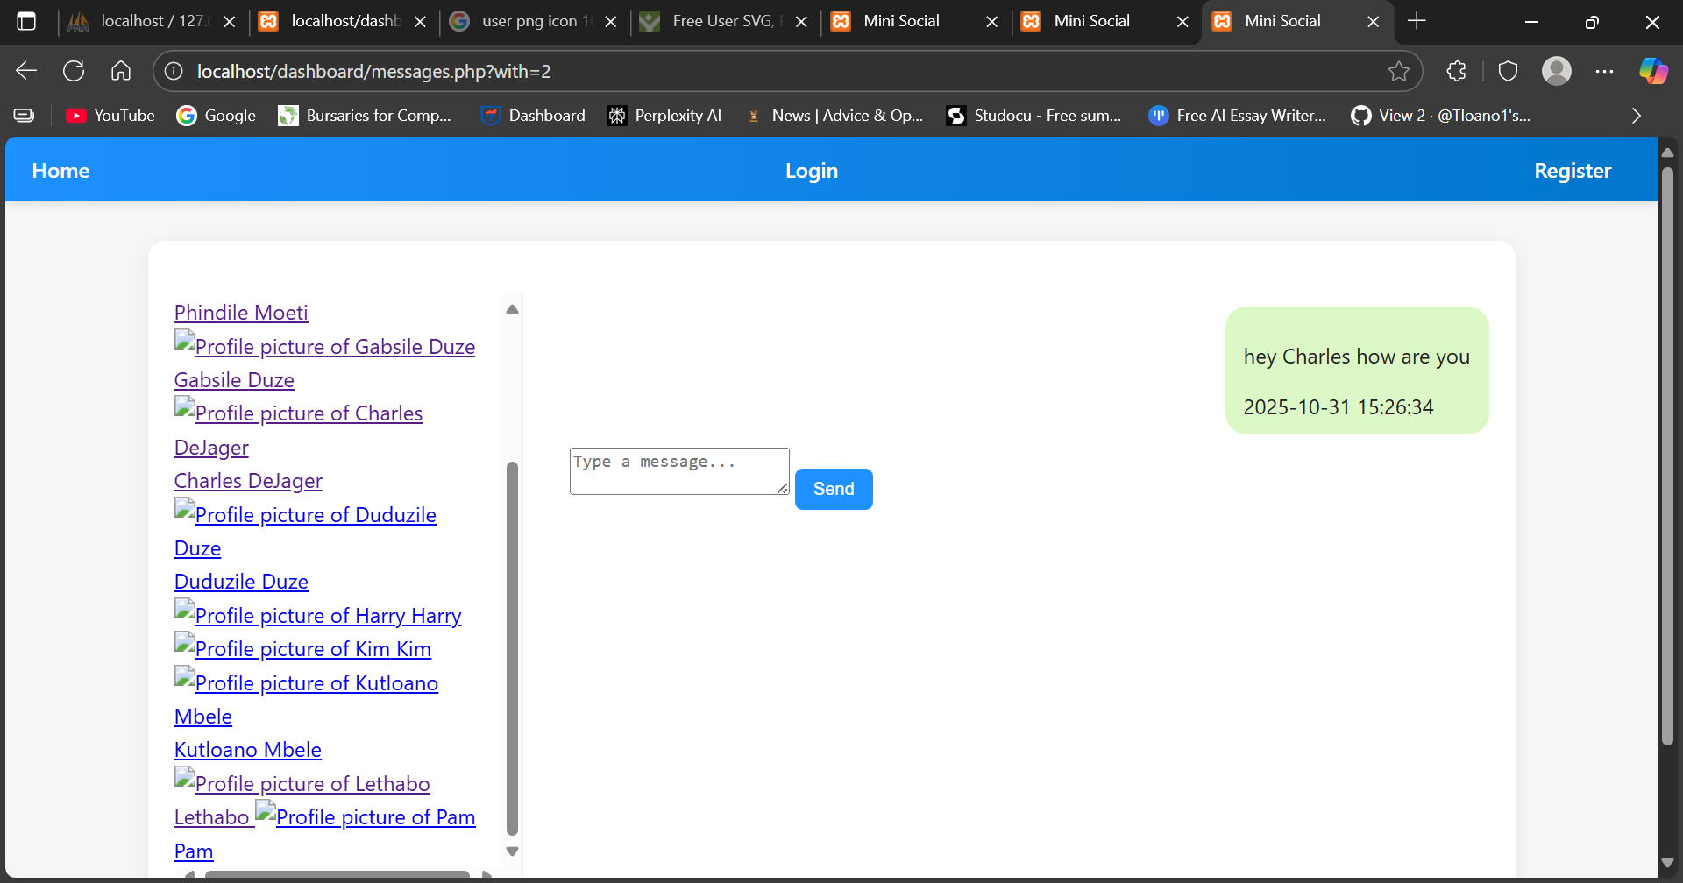

SQL Screenshots:

